
TRIBHUVAN UNIVERSITY
INSTITUTE OF SCIENCE AND TECHNOLOGY
MADAN BHANDARI MEMORIAL COLLEGE
A Final Project Report On
“AI NOTE ANALYZER BROWSER EXTENSION”

Under the Supervision of
Rhishav Poudyal, Lecturer, Madan Bhandari Memorial College

Submitted To:

DEPARTMENT OF COMPUTER SCIENCE AND INFORMATION TECHNOLOGY
MADAN BHANDARI MEMORIAL COLLEGE
In partial fulfilment of the requirements for the degree of
Bachelors of Science in Computer Science and Information Technology (B.Sc. CSIT)
Submitted By:
Arpan Poudel (79010988)
Devraj Silwal (79010998)
Yugal Poudel (79011030)

May, 2026

SUPERVISOR'S RECOMMENDATION
This is to certify that the project report entitled "AI Note Analyzer Browser Extension" has been prepared under my supervision by Arpan Paudel (Roll No: 79010988), Devraj Silwal (Roll No: 79010998), and Yugal Poudel (Roll No: 79011030), students of the Bachelor of Science in Computer Science and Information Technology (B.Sc. CSIT), 7th Semester, Madan Bhandari Memorial College, affiliated to Tribhuvan University, Institute of Science and Technology.
The project work has been carried out in the Department of Computer Science and Information Technology in partial fulfillment of the requirements for the degree of Bachelor of Science in Computer Science and Information Technology (B.Sc. CSIT) under the Faculty of Institute of Science and Technology, Tribhuvan University, Kathmandu, Nepal.
I hereby recommend this project report for evaluation and defense.

______________________________
Mr. Rhishav Poudyal
Supervisor
Lecturer, Department of CSIT
Madan Bhandari Memorial College
New Baneshwor, Kathmandu

LETTER OF APPROVAL
This is to certify that the project report entitled "AI Note Analyzer Browser Extension" submitted by Arpan Paudel (Roll No: 79010988), Devraj Silwal (Roll No: 79010998), and Yugal Poudel (Roll No: 79011030), students of B.Sc. CSIT, 7th Semester, Madan Bhandari Memorial College, has been examined and approved for the partial fulfillment of the requirements for the Bachelor of Science in Computer Science and Information Technology degree under Tribhuvan University, Institute of Science and Technology.
The project report has been found to be satisfactory for the partial fulfillment of the requirements for the degree of Bachelor of Science in Computer Science and Information Technology.
______________________________
Prajwal Bhandari
Program Coordinator
Department of CSIT, Madan Bhandari Memorial College

______________________________
Mr. Rhishav Poudyal
Supervisor
Madan Bhandari Memorial College

______________________________
External Examiner
Name: ________________________
Central Department of
Computer Science and IT,
Tribhuvan University,
Kritipur, Nepal

______________________________
Internal Examiner
Name: ________________________
Madan Bhandari Memorial College

ACKNOWLEDGEMENT
“First and foremost, we would like to express our sincere gratitude to Tribhuvan University, Institute of Science and Technology, for providing the academic framework and guidelines that have shaped the direction of this project.
We extend our deepest thanks to our project supervisor, Mr. Rhishav Poudyal, Lecturer, Department of Computer Science and Information Technology, Madan Bhandari Memorial College, for his constant guidance, constructive feedback, and encouragement throughout the development of this project. His expertise in the field of Computer Science and his willingness to address our queries at every stage of the project have been invaluable.
We are also grateful to Mr. Prajwal Bhandari, Head of the Department of Computer Science and Information Technology, Madan Bhandari Memorial College, for providing a supportive academic environment and for facilitating the resources and infrastructure necessary for carrying out this project work.
Our sincere appreciation goes to all the faculty members and staff of the Department of Computer Science and Information Technology, Madan Bhandari Memorial College, whose teachings during the course of our B.Sc. CSIT program have laid the foundation for the technical skills demonstrated in this project.
This report would not have been possible without the contributions of everyone mentioned above. We are forever grateful and honored to have had the opportunity to work with such exceptional individuals. Thank you."

Arpan Paudel
Devraj Silwal
Yugal Poudel

ABSTRACT
The widespread availability of digital academic resources has not simplified the challenge of comprehending complex academic content. Students continue to struggle with dense terminology and lengthy texts, often relying on multiple disconnected tools to simplify content, generate practice questions, and identify key concepts. This problem is further compounded by the need to switch between applications and tools, disrupting the flow of study.
This project presents the AI Note Analyzer, a browser extension that provides real-time academic support directly within the web browser. When a user selects text from any webpage or PDF document, the system performs four core operations: text simplification, exam-oriented question generation, keyword extraction, and difficulty assessment. All results are displayed in a floating, draggable panel within the browser. Results can be exported as PDF or Markdown reports, and all analyses are automatically saved in a browsable, searchable history.
The extension is built using JavaScript and the Chrome Extension API (Manifest V3), while the backend uses FastAPI and Python hosted on a cloud server. AI processing is handled using the FLAN-T5 instruction-tuning architecture for text simplification and question generation. Keyword extraction employs a weighted TF-IDF-style scoring pipeline using spaCy, incorporating named entity recognition, positional boosts, and noun-chunk-head weighting. Difficulty assessment uses a dual-metric approach combining average words per sentence and a simplified Flesch-Kincaid grade level formula. A fully functional system has been developed, tested, and deployed, with the browser extension published and available for installation on both Google Chrome and Microsoft Edge. Analysis results can be exported as a formatted PDF or Markdown file for offline use.
Keywords:
Browser Extension, Natural Language Processing, Text Simplification, Question
Generation, Keyword Extraction, FLAN-T5, spaCy, FastAPI, Flesch-Kincaid, Manifest V3

TABLE OF CONTENTS
SUPERVISOR'S RECOMMENDATION i
LETTER OF APPROVAL ii
ACKNOWLEDGEMENT iii
ABSTRACT iv
TABLE OF CONTENTS v
LIST OF FIGURES vii
LIST OF TABLES viii
LIST OF ABBREVIATIONS ix
CHAPTER 1: INTRODUCTION 1
1.1 Introduction 1
1.2 Problem Statement 2
1.3 Objectives 2
1.4 Scope and Limitations 3
1.4.1 Scope 3
1.4.2 Limitations 4
1.5 Development Methodology 4
1.6 Report Organization 5
CHAPTER 2: BACKGROUND STUDY AND LITERATURE REVIEW 7
2.1 Background Study 7
2.2 Literature Review 8
CHAPTER 3: SYSTEM ANALYSIS 10
3.1 System Analysis 10
3.1.1 Requirement Analysis 10
3.1.1.1 Functional Requirements 10
3.1.1.2 Non-Functional Requirements 11
3.1.2 Feasibility Study 12
3.1.2.1 Technical Feasibility 12
3.1.2.2 Operational Feasibility 12
3.1.2.3 Economic Feasibility 13
3.1.2.4 Schedule Feasibility 13
3.1.3 Analysis 13
3.1.3.1 Use Case Modelling using Use Case Diagram 13
3.1.3.2 Object Modelling using Class and Object Diagrams 15
3.1.3.3 Dynamic Modelling using state and sequence Diagrams 16
3.1.3.4 Process modelling using Activity Diagrams 19
CHAPTER 4: SYSTEM DESIGN 22
4.1 Design 22
4.1.1 Refinement of Class, Object, State, Sequence and Activity diagrams 22
4.1.2 Component Diagrams 24
4.1.3 Deployment Diagrams 26
4.2 Algorithm Details 27
CHAPTER 5: IMPLEMENTATION AND TESTING 31
5.1 Implementation 31
5.1.1 Tools Used 31
5.1.2 System Implementation 32
5.1.2.1 Browser Extension Module 32
5.1.2.2 Backend Processing Module 33
5.1.2.3 Inter-Module Communication 33
5.2 Testing 34
5.2.1 Unit Testing 34
5.2.2 Integration Testing 36
5.2.3 System Testing 38
5.3 Result Analysis 39
CHAPTER 6: CONCLUSION AND FUTURE RECOMMENDATIONS 41
6.1 Conclusion 41
6.2 Future Recommendations 42
REFERENCES 44
APPENDIX A: GITHUB REPOSITORY AND CODE STRUCTURE 45
APPENDIX B: SCREENSHOTS OF THE SYSTEM 46
APPENDIX C: MAJOR SOURCE CODE SNIPPETS 49
C.1 content.js — Text Selection and API Call Logic 49
C.2 main.py — FastAPI Endpoint Definitions 49
C.3 simplifier.py — FLAN-T5 Routing Strategy 49
C.4 keyword_extractor.py — Weighted Scoring Pipeline 49
C.5 difficulty_detector.py — Dual-Metric Classification 50
C.6 question_generator.py — Concurrent Question Generation 50
C.7 render.yaml — Cloud Deployment Configuration 50

LIST OF FIGURES
Figure 3.1: Use Case Diagram of AI Note Analyzer System 14
Figure 3.2: Class Diagram of the AI Note Analyzer System 16
Figure 3.3: Object Diagram of the AI Note Analyzer System 16
Figure 3.4: State Diagram- Browser Extension Panel 17
Figure 3.5: State Diagram- AnalysisRequest Lifecycle 17
Figure 3.6: Sequence Diagram – Text Simplification Use Case 18
Figure 3.7: Sequence Diagram – Question Generation Use Case 19
Figure 3.8: Activity Diagram – Core Analysis Workflow 20
Figure 3.9: Activity Diagram – Export Workflow 20
Figure 3.10: Activity Diagram – History Management Workflow 21
Figure 4.1: Refined Sequence Diagram with Method Signatures and Data Types 23
Figure 4.2:Refined Sequence Diagram with Error-Handling Frames 23
Figure 4.3: Refined Activity Diagram with Swimlanes 24
Figure 4.4: Component Diagram of the AI Note Analyzer System 25
Figure 4.5: Deployment Diagram of the AI Note Analyzer System 27

LIST OF TABLES
Table 5.1: Tools and Technologies Used 31
Table 5.2: Inter-Module Communication Protocol 34
Table 5.3: Unit Test Cases 35
Table 5.4: Integration Test Cases 37

LIST OF ABBREVIATIONS
Abbreviation | Full Form
AI | Artificial Intelligence
NLP | Natural Language Processing
API | Application Programming Interface
REST | Representational State Transfer
PDF | Portable Document Format
UI | User Interface
HTML | Hypertext Markup Language
CSS | Cascading Style Sheets
JS | JavaScript
JSON | JavaScript Object Notation
HTTP | Hypertext Transfer Protocol
DOM | Document Object Model
FLAN-T5 | Fine-tuned Language Net - Text-to-Text Transfer Transformer
POS | Part-of-Speech
ASGI | Asynchronous Server Gateway Interface
Seq2Seq | Sequence-to-Sequence
NLTK | Natural Language Toolkit
TF-IDF | Term Frequency-Inverse Document Frequency
NER | Named Entity Recognition
FK | Flesch-Kincaid
UUID | Universally Unique Identifier
MV3 | Manifest Version 3
FPDF2 | Free PDF Generation Library Version 2
CORS | Cross-Origin Resource Sharing
CRUD | Create, Read, Update, Delete
CSIT | Computer Science and Information Technology
TU | Tribhuvan University

CHAPTER 1: INTRODUCTION

1.1 Introduction
In recent years, digital learning has become an integral part of academic life. Study materials such as PDFs, eBooks, lecture slides, research articles, and online notes are now widely available, making information more accessible than ever before. However, the accessibility of information does not always translate into ease of understanding. Complex academic language, dense technical content, and lengthy research texts continue to present significant challenges for students at all levels.
Students often invest considerable time and effort in simplifying content into their own words, identifying key concepts, and anticipating possible examination questions. These practices are educationally valuable but also mentally demanding and time-consuming. Many students either skip difficult sections altogether or depend heavily on secondary sources such as guidebooks and summaries, which may not always capture the depth of the original material.
With the rapid advancement of Artificial Intelligence (AI) and Natural Language Processing (NLP), computers have gained the ability to analyze, interpret, and generate human language with increasing accuracy [1]. These capabilities present a meaningful opportunity to assist students in their learning process by automating tasks that would otherwise require significant cognitive effort.
This project presents the development of the AI Note Analyzer, a browser extension that provides real-time academic support directly within the web browser. When a user selects any paragraph from a webpage or PDF document, the system automatically performs four core operations: it simplifies the selected text into easier language, generates possible exam-oriented questions, extracts key concepts and keywords, and assesses the difficulty level of the content. Results are displayed in a floating, draggable, and minimizable in-page panel. All previous analyses are saved in a browsable, searchable history, and results can be exported as a formatted PDF report or a Markdown file for offline use.
The system is built using a client-server architecture. The browser extension, developed using JavaScript and the Chrome Extension API (Manifest V3), serves as the user-facing interface. The backend, built with FastAPI and Python, handles all AI processing. Text simplification and question generation follow the FLAN-T5 instruction-tuning paradigm, utilizing a sentence-routing strategy and quality-guard mechanisms [2]. Keyword extraction is performed by spaCy using a weighted scoring pipeline that incorporates Term Frequency, Inverse Document Frequency proxy, Named Entity Recognition boosts, and positional weighting [3]. Difficulty assessment uses a dual-metric approach combining average words per sentence and a simplified Flesch-Kincaid grade level formula. The backend is deployed on a cloud server, and the extension communicates with it through REST API calls, keeping the extension lightweight while offloading computation to the server.

1.2 Problem Statement
The increasing availability of online academic resources has made information more accessible, but students still face difficulties in understanding complex study materials containing technical vocabulary and lengthy sentence structures. Existing tools mainly focus on grammar correction, paraphrasing, or summarization and do not provide an integrated solution for academic comprehension. As a result, students often rely on multiple disconnected tools and manual effort to simplify content, identify key concepts, and prepare study questions.
Furthermore, existing browser-based tools require users to copy text, switch applications, and manually piece together information from different sources. This workflow interrupts the study process and reduces learning efficiency. PDF documents present an additional challenge as most tools cannot process text from PDF files opened in the browser.
To address these issues, this project proposes an AI-powered browser extension that provides real-time academic assistance directly within the browser environment. The system integrates text simplification, question generation, keyword extraction, and difficulty assessment into a single floating panel accessible on any webpage or PDF, thereby eliminating the need for multiple disconnected tools.

1.3 Objectives
The primary objective of this project is to develop an AI-powered browser extension that assists students in comprehending academic content and preparing for examinations more effectively.
The specific objectives are as follows:
- To design and develop a browser-based academic assistance tool that captures user-selected text directly from any webpage without requiring manual copy-paste interaction
- To simplify complex academic text into clear, easier language using a transformer-based NLP model (FLAN-T5)
- To automatically generate exam-oriented practice questions from the selected text using sequence-to-sequence generation techniques
- To extract key concepts and domain-relevant keywords from the selected text using Part-of-Speech tagging with spaCy

1.4 Scope and Limitations

1.4.1 Scope
- Browser-Based Operation: The system operates as a Chrome and Microsoft Edge browser extension, processing any English text selected from publicly accessible webpages without requiring separate applications.
- Four Core NLP Features: Text simplification, exam-oriented question generation, keyword extraction, and difficulty assessment as primary functionalities, displayed in a floating, draggable, and minimizable in-page panel.
- Client-Server Architecture: The extension handles user interaction while all AI processing is offloaded to a FastAPI backend using the FLAN-T5 instruction-tuning architecture and spaCy NLP models.
- History and Export: Users can export analysis results as PDF or Markdown reports and access previously analyzed content through a searchable history interface.
- Deployment and Accessibility: The backend is hosted on a public cloud server (Render, Singapore region) and the extension is packaged and available for direct installation on Chrome and Edge browsers.
- Academic Comprehension Focus: The system is specifically designed for student use, targeting comprehension of web-based and PDF-based study materials and examination preparation.

1.4.2 Limitations
- Internet Dependency: The text simplification and question generation features require a stable internet connection since AI inference is handled on a remote backend server. Keyword extraction, difficulty assessment, Markdown export, and history search operate independently.
- Token Length Constraint: The FLAN-T5 architecture has a maximum input length, meaning very long texts are trimmed to a 5,000-character limit before processing. A visible notice is shown in the panel when trimming occurs.
- Rule-Based Difficulty Assessment: Difficulty analysis relies on sentence length and syllable-based metrics, which may not accurately reflect the true complexity of highly specialized academic content.
- No User Authentication: The system does not include user login or account management. Analysis history is stored locally in the extension and is not synchronized across devices. On the cloud-hosted backend, history persistence is disabled due to the ephemeral filesystem of the free hosting tier.
- Cold Start Latency: The backend is hosted on a free tier cloud service. After a period of inactivity, the first request may take 30 to 60 seconds as the server resumes from idle state.

1.5 Development Methodology
The development of the AI Note Analyzer Browser Extension followed the Agile (Scrum) methodology, which supports iterative and incremental development. This approach was chosen because the project required continuous testing and refinement of AI processing features, and feedback from testing needed to be incorporated at each stage of development.
The development was organized into sprints of approximately two weeks each. At the beginning of every sprint, tasks were planned and committed to a set of deliverables. Regular progress reviews were conducted to identify issues and adjust priorities. The Scrum framework allowed the team to remain focused on development goals while responding efficiently to changes in technical requirements or implementation challenges.

The major phases of development included:
- Requirement Analysis: Identifying functional and non-functional requirements, reviewing related literature, and finalizing the system scope.
- System Design: Designing the client-server architecture, working mechanism, algorithm flows, and user interface layouts.
- Implementation: Developing the browser extension frontend and the FastAPI backend, integrating the FLAN-T5 instruction-tuning pipeline, spaCy keyword extraction, and the dual-metric difficulty assessment module.
- Integration and Testing: Connecting all modules, testing API communication, and validating outputs for accuracy and reliability across unit, integration, and system testing phases.
- Deployment and Review: Hosting the backend on the Render cloud platform, packaging and publishing the browser extension for Chrome and Edge, and conducting final system testing in the production environment.
This iterative approach ensured a functional prototype was available early in the development cycle, and subsequent sprints were used to refine features, resolve issues, and add capabilities such as PDF export, Markdown export, history search, keyboard shortcut, and options page.

1.6 Report Organization
The remainder of this report is organized as follows:
Chapter 1: Introduction presents the background of the project, problem statement, objectives, scope and limitations, development methodology, and the overall organization of this report.
Chapter 2: Background Study and Literature Review present fundamental concepts related to Artificial Intelligence, Natural Language Processing, transformer-based language models, and browser extension technologies. It also reviews relevant existing research and related systems.
Chapter 3: System Analysis describes the requirement analysis of the proposed system, covering functional and non-functional requirements, feasibility analysis across technical, operational, economic, and schedule dimensions, and use case modeling.
Chapter 4: System Design presents the overall system design including the working mechanism, client-server architecture, and detailed descriptions of the algorithms used for text simplification, question generation, keyword extraction, and difficulty assessment.
Chapter 5: Implementation and Testing cover the tools and technologies used, the project structure, implementation details of all system modules, inter-module communication, testing strategies, test cases, result analysis, and configuration management.
Chapter 6: Conclusion and Future Recommendations summarize the project outcomes, reflects on the achievement of stated objectives, and outlines potential future improvements and extensions.

CHAPTER 2: BACKGROUND STUDY AND LITERATURE REVIEW

2.1 Background Study
The rapid growth of digital learning platforms and online academic resources has transformed the way students access educational content. Research articles, lecture notes, eBooks, and online tutorials are now widely available through the internet. However, despite the increased accessibility of information, students still face difficulties in understanding complex academic language and extracting important concepts from lengthy study materials.
Artificial Intelligence and Natural Language Processing have introduced new possibilities for improving educational support systems. NLP enables computers to process, analyze, and generate human language, making it possible to automate tasks such as text simplification, question generation, summarization, and keyword extraction. These technologies are increasingly being applied in educational applications to support learning and improve comprehension.
Transformer-based language models have shown significant improvements in text generation and language understanding tasks. The Text-to-Text Transfer Transformer and its instruction-fine-tuned variant FLAN-T5 demonstrated that framing all NLP tasks as text generation problems, combined with instruction-based learning, produces models capable of high-quality outputs across a wide range of tasks. The FLAN-T5 architecture is particularly relevant to this project because its instruction-tuning approach allows the model to simplify text and generate questions from a structured prompt, without requiring task-specific training from scratch.
NLP libraries such as spaCy provide efficient tools for tokenization, Part-of-Speech tagging, Named Entity Recognition, and noun chunk detection [6]. These capabilities form the foundation of the keyword extraction module in this project. The Flesch-Kincaid readability formula, a well-established linguistic metric, provides a reliable basis for assessing the reading difficulty of text based on sentence length and syllable complexity.
Browser extensions have become a practical mechanism for integrating intelligent assistance directly into users' browsing environments. By combining Chrome Extension API technologies with AI-based NLP processing through a client-server architecture, educational support systems can provide real-time assistance without requiring users to install additional applications or switch between tools.

2.2 Literature Review
The following review covers key works in the areas of transformer-based language models, automatic question generation, keyword extraction, and NLP frameworks that are directly relevant to the design and implementation of this project.
The T5 model treats all NLP tasks as text generation problems using a unified text-to-text framework. This approach demonstrated strong performance in tasks such as text simplification, translation, and question answering. The FLAN-T5 instruction-tuning architecture used in this project is built upon this foundation, preserving the sentence-routing and quality-guard structure of the original T5 approach [1].
Further development of transformer-based language models through instruction fine-tuning demonstrated that instruction-tuned models generate more accurate and context-aware responses across multiple NLP tasks, making the FLAN-T5 architecture suitable for both text simplification and automatic question generation in educational systems such as the one presented in this project [2].
Neural sequence-to-sequence learning models have been shown to generate meaningful questions from reading passages, supporting applications in educational technology and assessment preparation. The concurrent per-sentence question generation approach implemented in this project is informed by this line of research. Statistical approaches for automatic question generation and ranking have highlighted the importance of generating grammatically correct and contextually relevant questions from textual content, with filtering mechanisms proposed to remove low-quality outputs. The quality-guard and deduplication mechanisms in this project's question generation module reflect similar design concerns [4].
The TextRank algorithm demonstrated how graph-based NLP techniques can identify important concepts and keywords from documents, which is useful for improving comprehension and summarization tasks. The weighted scoring approach used in this project extends this idea by incorporating TF-IDF, named entity recognition, and positional signals [5].
Foundational NLP techniques using Python, including tokenization, stopword removal, and text preprocessing, form the basis of many NLP systems, including the sentence tokenization pipeline used in this project. A comprehensive treatment of readability metrics, including the Flesch-Kincaid formula, provides the theoretical basis for difficulty assessment in text-based systems [7]. The dual-metric difficulty assessment module in this project applies the simplified Flesch-Kincaid grade level formula as described in this reference.
The Manifest V3 standard defines the current technical specifications for browser extension development, covering the service worker model, content scripts, and declarative permissions[8]. The extension in this project is built in full compliance with these requirements.
Although existing systems and research provide useful approaches for text processing and educational support, most available tools focus only on individual tasks such as paraphrasing, summarization, or grammar correction. Very few systems integrate text simplification, question generation, keyword extraction, and difficulty assessment into a single browser-based platform. The proposed system addresses this gap by providing a fully integrated AI-powered study assistant directly within the browser environment, with additional features such as PDF and Markdown export, history search, and keyboard shortcut access.

CHAPTER 3: SYSTEM ANALYSIS

3.1 System Analysis
System analysis involves a thorough examination of the problem domain, identification of system requirements, and evaluation of the feasibility of the proposed solution prior to implementation. This section presents the requirement analysis, feasibility study, and system models derived during the analysis phase of the AI Note Analyzer Browser Extension.

3.1.1 Requirement Analysis
Requirement analysis identifies and documents the needs of the system's intended users and stakeholders, serving as the primary input for system design. The requirements for the AI Note Analyzer Browser Extension are categorized into functional requirements, which describe the specific operations the system must perform, and non-functional requirements, which define the quality attributes and constraints the system must satisfy.

3.1.1.1 Functional Requirements
Functional requirements define the specific behaviors and operations the system must perform to meet the needs of its intended users. The following functional requirements were identified for the AI Note Analyzer Browser Extension:
- The system shall capture selected text from any webpage using the DOM Selection API (window.getSelection()) via the content script.
- The system shall simplify complex academic paragraphs into easier language using the FLAN-T5 instruction-tuning architecture with sentence-level routing.
- The system shall generate up to five exam-oriented questions from selected text using a concurrent Sequence-to-Sequence generation approach, with quality-guard filtering and deduplication.
- The system shall extract meaningful keywords from selected text using a weighted scoring pipeline incorporating Term Frequency, IDF proxy, Named Entity Recognition boost, positional boost, and noun-chunk-head weighting via spaCy.
- The system shall assess the difficulty level of selected text using a dual-metric approach: average words per sentence and a simplified Flesch-Kincaid grade level formula.
- The extension shall display all results in a floating, draggable, and minimizable in page panel with tabbed navigation (Simplified, Questions, Keywords, Difficulty, History).
- Users shall be able to export analysis results as a formatted PDF report via the export-pdf backend endpoint.
- Users shall be able to export analysis results as a Markdown file entirely on the client side, without a backend call.
- The system shall maintain a UUID-based, thread-safe history of all previous analyses, accessible and searchable from within the extension.
- The extension shall support a keyboard shortcut (Alt+S) to toggle the analysis panel from any webpage.
- The extension shall provide a settings page (Options page) for configuring the backend API URL, character limit, and PDF redirect behavior.

3.1.1.2 Non-Functional Requirements
Non-functional requirements define the quality attributes, performance constraints, and operational standards the system must satisfy beyond its core functional behavior. The following non-functional requirements were identified for the AI Note Analyzer Browser Extension:
- The application shall be user-friendly and easy to operate with minimal learning curve, requiring no local installation beyond loading the browser extension.
- The system shall provide results within a reasonable response time. Keyword extraction and difficulty assessment shall respond in under one second. Text simplification and question generation shall complete within the 120-second timeout window under normal network conditions.
- The output shall be reliable and semantically meaningful, with quality-guard mechanisms in place to detect and discard low-quality model outputs.
- The software shall run on Google Chrome (version 102 or above) and Microsoft Edge, as specified in the extension manifest.
- The extension shall remain lightweight by offloading heavy AI computation to the backend server, ensuring minimal impact on browser performance.
- The system shall handle errors gracefully, displaying user-facing error messages for backend unavailability, request timeouts, and empty text selection, with a Retry option for failed requests.
- The history storage shall be thread-safe, using a threading lock and atomic write operations to prevent data corruption under concurrent access.

3.1.2 Feasibility Study
A feasibility study evaluates whether the proposed system can be successfully developed and deployed within the available resources, technical capabilities, and time constraints. The feasibility of the AI Note Analyzer Browser Extension was assessed across four dimensions: technical, operational, economic, and schedule feasibility.

3.1.2.1 Technical Feasibility
The project is technically feasible as it uses accessible and widely adopted technologies. The browser extension is developed using HTML, CSS, and JavaScript with the Chrome Extension Manifest V3 API. The backend uses Python-based AI and NLP libraries including FastAPI, spaCy, NLTK, and FPDF2. The FLAN-T5 instruction-tuning architecture is applied through an API-based inference service, eliminating the need for local GPU resources. Open-source tools and pre-trained models are available, making development manageable within the project timeline and resource constraints.

3.1.2.2 Operational Feasibility
The system is straightforward to operate for students. The extension installs in three steps and requires no configuration for standard use. Selecting text triggers the analysis panel automatically. The tabbed interface, keyboard shortcut, and history search make the tool accessible without any prior training. Analysis results can be exported as PDF or Markdown files for offline reference.

3.1.2.3 Economic Feasibility
The project is cost-effective. All required tools, libraries, and models are open-source or available on free tiers. The backend is hosted on Render's free hosting tier at no cost. No additional hardware investment is needed. The extension is distributed as a zip package and loaded directly into the browser, requiring no paid publishing fees for the current deployment.

3.1.2.4 Schedule Feasibility
The project was completed within the 12-week semester timeline. The Agile (Scrum) methodology with two-week sprints ensured that development milestones were met without overloading any single phase. Requirement analysis, design, implementation, integration, testing, and deployment were each completed within their allocated time windows.

3.1.3 Analysis
The system has one primary actor: the student (User). The use cases cover the complete set of interactions a student can perform with the AI Note Analyzer extension. The following subsections present the object, dynamic, and process models derived from the requirements analysis, using standard UML notation.

3.1.3.1 Use Case Modelling using Use Case Diagram
Use case modelling is used to represent the interaction between the user and the proposed system. It helps identify the functional requirements of the system and illustrates how the user interacts with the browser extension to perform different operations. The use case diagram provides a clear overview of the major functionalities available in the AI Note Analyzer Browser Extension.
In the proposed system, the student acts as the primary actor who interacts with the browser extension. The student can select academic text from webpages or digital study materials and use different features provided by the system to simplify content and improve understanding.
The major use cases included in the system are described below:
- SelectText: Allows the student to highlight or select academic content from webpages, PDFs, or study materials for further analysis. It acts as the primary input operation of the system.
- SimplifyText: Uses the FLAN-T5 instruction-tuning architecture to transform complex academic content into simpler and easier-to-understand language.
- GenerateQuestions: Uses the FLAN-T5 instruction-tuning architecture to generate exam-oriented questions from the selected academic text.
- ExtractKeywords: Implements a weighted TF-IDF scoring pipeline using spaCy with Named Entity Recognition (NER), positional weighting, and noun-chunk analysis to identify important keywords.
- AssessDifficulty: Applies a dual-metric approach combining average words per sentence and Flesch Reading Ease Score to estimate the complexity level of the selected text.
- ViewHistory: Allows students to access previously analyzed content and review past simplifications, generated questions, and extracted keywords.
- ExportResult: Enables users to export processed outputs for future study and offline accessibility.
- ConfigureSettings: Allows users to customize browser extension preferences, API configurations, and system behavior according to requirements.
The use case diagram presented in Figure 3.1 illustrates the interaction between the student and the major functionalities of the proposed AI Note Analyzer Browser Extension system. The diagram highlights how different system features depend on text selection before performing analysis-related operations.
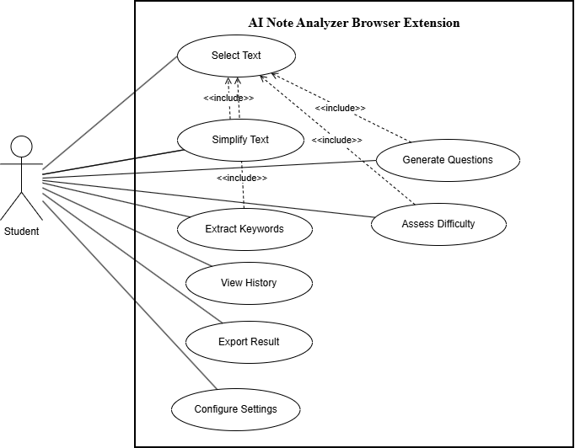

Figure 3.1: Use Case Diagram of AI Note Analyzer System

3.1.3.2 Object Modelling using Class and Object Diagrams
Object modelling captures the static structure of the AI Note Analyzer system by identifying the key entities, their attributes, and the relationships among them. The class diagram identifies the following primary classes:
- Student (User): Represents the end user who interacts with the browser extension.
Attributes include user preferences and analysis history.
- BrowserExtension: The front-end component that captures selected text and displays results. It manages the floating panel, export controls, and history view.
- AnalysisRequest: Encapsulates the selected text and the requested analysis type
(simplification, question generation, keyword extraction, or difficulty assessment).
- BackendAPI (FastAPI Server): Receives requests from the extension, routes them to the appropriate processing module, and returns structured results.
- TextSimplifier: Uses the FLAN-T5 model to produce simplified versions of selected academic text.
- QuestionGenerator: Uses the FLAN-T5 instruction-tuning architecture to generate exam-oriented questions from the input text.
- KeywordExtractor: Implements a weighted TF-IDF scoring pipeline using spaCy with NER, positional boosts, and noun-chunk-head weighting.
- DifficultyAssessor: Applies a dual-metric approach combining average words per sentence and a Flesch-Kincaid grade level formula.
- AnalysisResult: Stores the output of an analysis operation, including the result content, timestamp, and analysis type.
- HistoryManager: Manages the browsable and searchable history of past analysis results within the extension.
- ExportModule: Handles the export of results as PDF or Markdown files.
The BrowserExtension aggregates the AnalysisRequest and AnalysisResult objects. The BackendAPI is associated with all four processing modules (TextSimplifier, QuestionGenerator, KeywordExtractor, DifficultyAssessor). The HistoryManager and ExportModule are components of the BrowserExtension.
The object diagram illustrates a concrete snapshot of the system during a typical interaction, where a student object has selected text from a webpage, an AnalysisRequest object has been created, and the BackendAPI has returned an AnalysisResult object that is displayed in the floating panel.
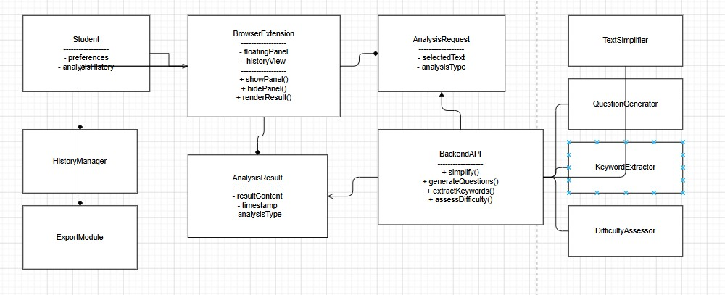
Figure 3.2: Class Diagram of the AI Note Analyzer System
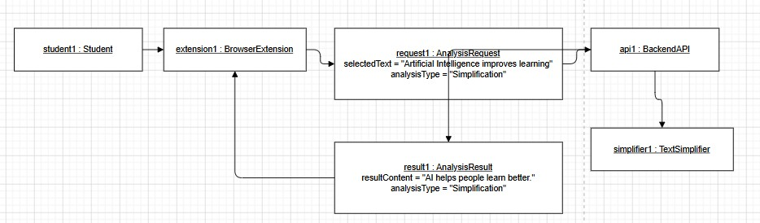
Figure 3.3: Object Diagram of the AI Note Analyzer System

3.1.3.3 Dynamic Modelling using state and sequence Diagrams
Dynamic modelling captures the behavior of the system over time. Two types of diagrams are used: state diagrams, which describe the lifecycle of key objects, and sequence diagrams, which show the interactions between objects for a specific use case.
State Diagram — Browser Extension Panel: The floating panel of the browser extension transitions through the following states: Idle (no text selected), Text Selected (user has highlighted text on the page), Request Sent (the extension has dispatched an API call to the backend), Processing (awaiting response from the backend), Result Displayed (the analysis result is shown in the panel), and History Viewed (the user is browsing past analyses). Transitions are triggered by user actions such as text selection, button clicks, and API response events.
State Diagram — AnalysisRequest Lifecycle: An AnalysisRequest object begins in a Created state when the user selects text, moves to a Submitted state when sent to the backend, enters an In-Progress state during processing, and terminates in either a Completed state (on success) or a Failed state (on network or processing error).
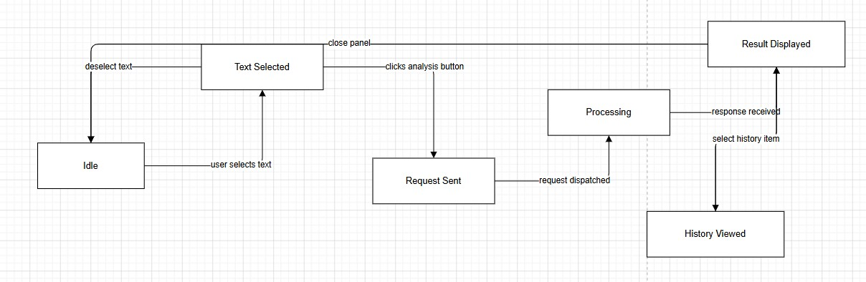
Figure 3.4: State Diagram- Browser Extension Panel
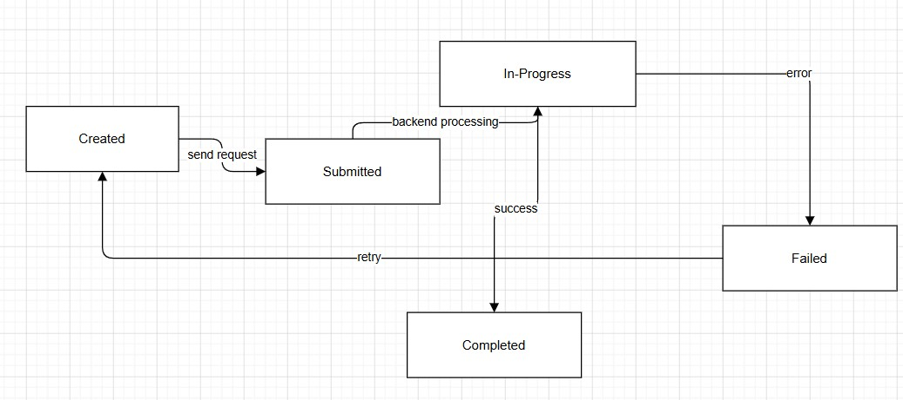
Figure 3.5: State Diagram- AnalysisRequest Lifecycle
Sequence Diagram — Text Simplification: This diagram depicts the interaction sequence when a student requests text simplification. The Student selects text on a webpage; the BrowserExtension captures the selection and displays the floating panel; the Student clicks the 'Simplify' button; the extension sends an HTTP POST request to the BackendAPI; the API routes the request to the TextSimplifier module; the FLAN-T5 model processes the input and returns simplified text; the BackendAPI returns the result as a JSON response; the BrowserExtension renders the result in the panel; and the HistoryManager saves the result for future reference.
Sequence Diagram — Question Generation: A similar interaction sequence is followed for question generation. The primary difference is that the BackendAPI routes the request to the QuestionGenerator module, which uses the FLAN-T5 architecture to produce a list of exam-oriented questions that are returned and rendered in the panel.
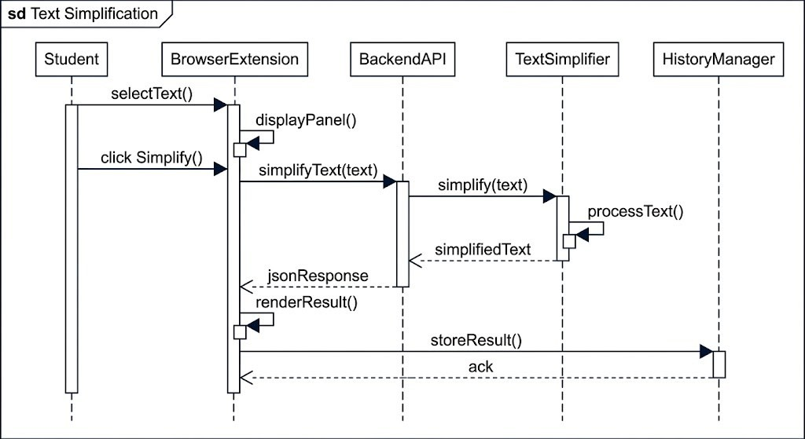
Figure 3.6: Sequence Diagram – Text Simplification Use Case

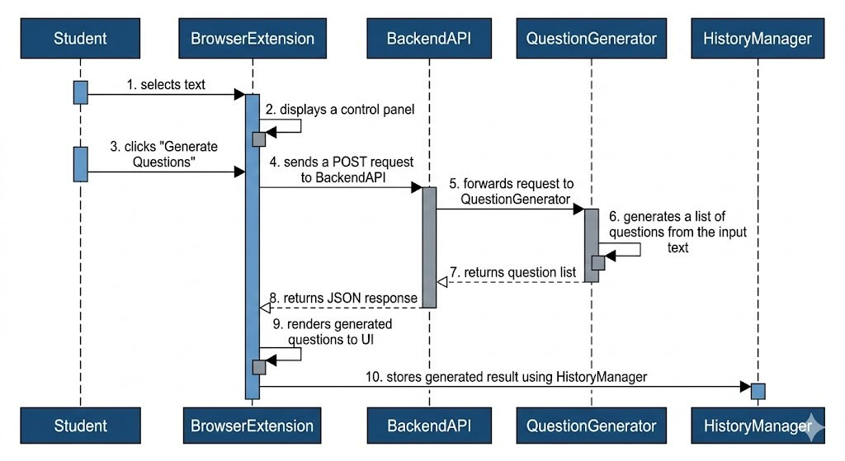
Figure 3.7: Sequence Diagram – Question Generation Use Case

3.1.3.4 Process modelling using Activity Diagrams
Process modelling using activity diagrams captures the workflow and control flow of the system's key operations. Activity diagrams show the sequence of activities, decision points, parallel flows, and termination conditions.
Activity Diagram — Core Analysis Workflow: The main workflow begins when the student selects text on any webpage or PDF document. The extension detects the selection and displays the analysis panel. The student selects an analysis type (Simplify, Generate Questions, Extract Keywords, or Assess Difficulty). The extension constructs the request payload and sends it to the backend. A decision node checks whether the backend is reachable: if not, an error message is displayed and the process terminates at the Idle state; if yes, the backend routes the request to the appropriate processing module. The module processes the text and returns a structured result. The extension renders the result in the floating panel and simultaneously stores it in the history log. The student may then choose to export the result (branching to the export sub-process) or close the panel and return to the Idle state.
Activity Diagram — Export Workflow: When the student opts to export a result, the activity diagram branches into two parallel flows based on the selected format. In the PDF export path, the extension formats the result data into a structured document layout and invokes the browser's PDF generation API. In the Markdown export path, the result is serialised into a plain-text Markdown format. Both paths converge at a file download activity, after which the student is returned to the Result Displayed state.
Activity Diagram — History Management: The student may open the history panel at any time. The system retrieves all stored AnalysisResult entries and displays them in reverse-chronological order. The student may search by keyword or filter by analysis type. Selecting a history entry re-displays the corresponding result in the panel, allowing the student to re-export or review previous analyses without making a new API call.

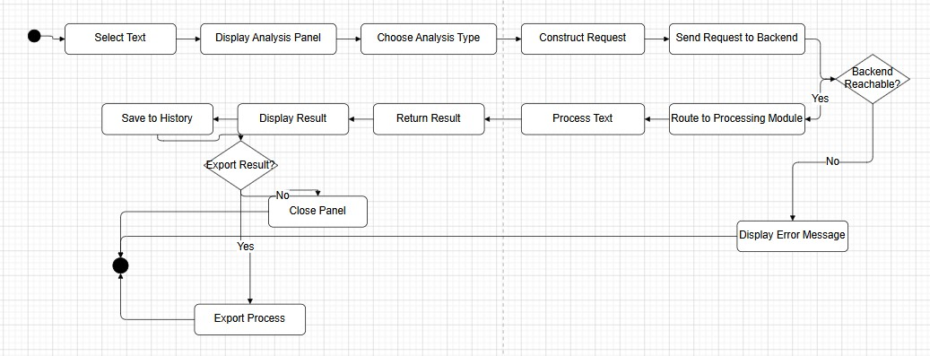
Figure 3.8: Activity Diagram – Core Analysis Workflow
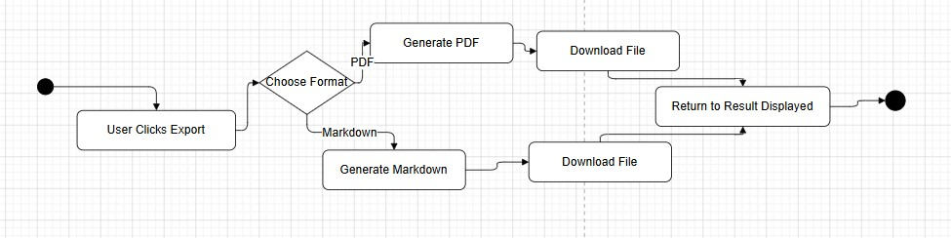
Figure 3.9: Activity Diagram – Export Workflow

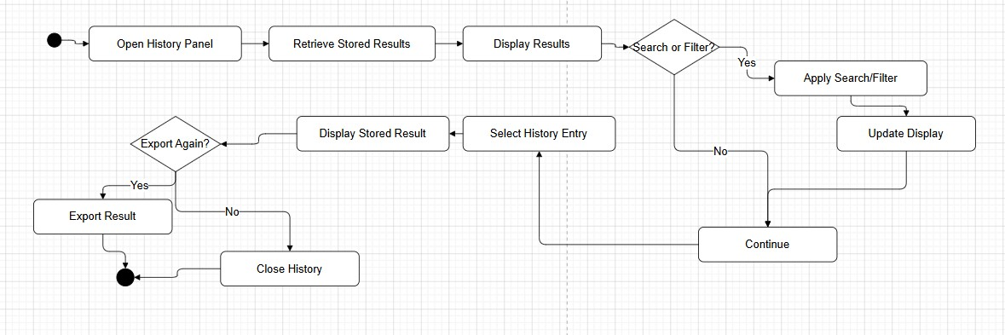
Figure 3.10: Activity Diagram – History Management Workflow

CHAPTER 4: SYSTEM DESIGN

4.1 Design
System design translates the requirements and analysis models into a concrete blueprint for implementation. This chapter presents the refined UML diagrams from the analysis phase, followed by component and deployment diagrams that describe the physical and logical architecture of the AI Note Analyzer system.

4.1.1 Refinement of Class, Object, State, Sequence and Activity diagrams
During the design phase, the analysis-level diagrams are refined to incorporate implementation-level details such as method signatures, data types, interface definitions, and technology-specific constraints. The following refinements were made:
Refined Class Diagram: Method signatures and data types were added to all classes to improve clarity and structure. For example, the BackendAPI class now includes methods such as simplify(), generate_questions(), extract_keywords(), and assess_difficulty(), each returning their respective response types. The BrowserExtension class contains methods for panel control, including showPanel(), hidePanel(), and renderResult(), as well as export functions like exportPDF() and exportMarkdown(). In addition, the dependency and realisation relationships between the BackendAPI and its processing modules are now clearly represented.
Refined Object Diagram: The object diagram is updated to reflect a complete interaction scenario including actual attribute values consistent with the system's data contracts, such as the JSON structure of API responses.
Refined State Diagrams: Guard conditions and actions are added to all transitions. For instance, the transition from Text Selected to Idle includes the guard [panel closed by user] and the action clearSelection(). Error-handling states are made explicit with transitions from the In-Progress state to a Failed state triggered by the condition [API timeout or HTTP error], followed by a recovery transition back to Idle after displaying the error message.
Refined Sequence Diagrams: Lifelines are updated to include the specific FastAPI route handlers and Python processing modules. Asynchronous messaging notation is used to represent the non-blocking HTTP communication between the browser extension and the backend. Error-handling alternative frames (alt) are added to show the flow when the backend returns a non-200 HTTP status code.
Refined Activity Diagrams: Swimlane notation is applied to distinguish activities performed by the Browser Extension (client side) from those performed by the Backend Server. Object flow nodes are added to show the AnalysisRequest and AnalysisResult objects passing between swimlanes.
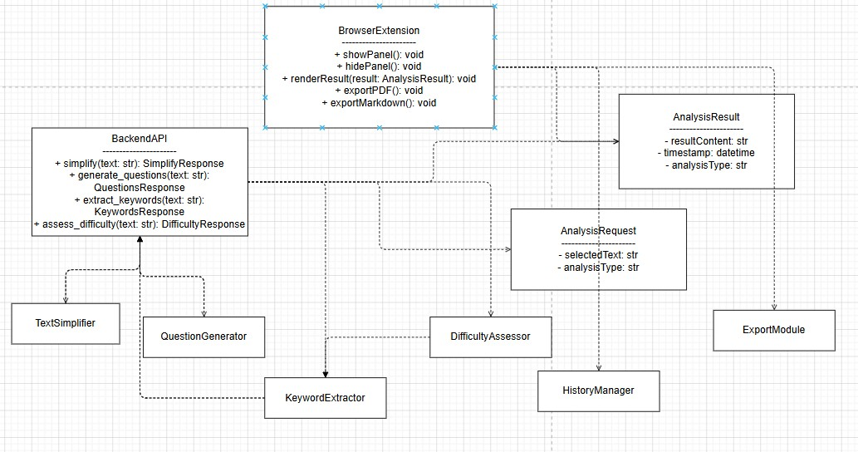

Figure 4.1: Refined Sequence Diagram with Method Signatures and Data Types

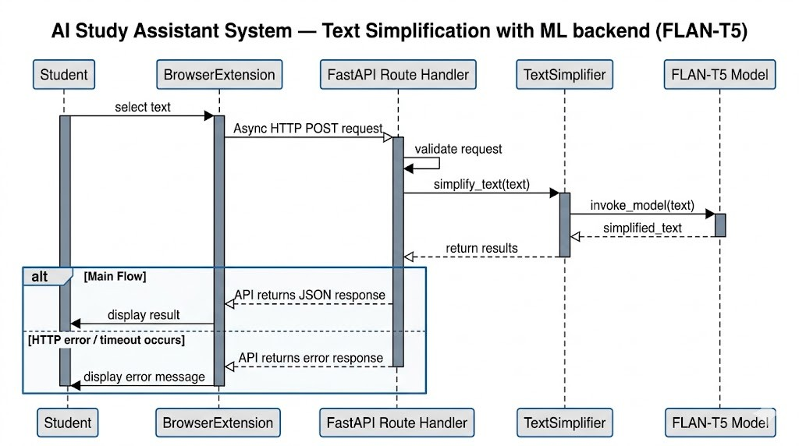

Figure 4.2:Refined Sequence Diagram with Error-Handling Frames

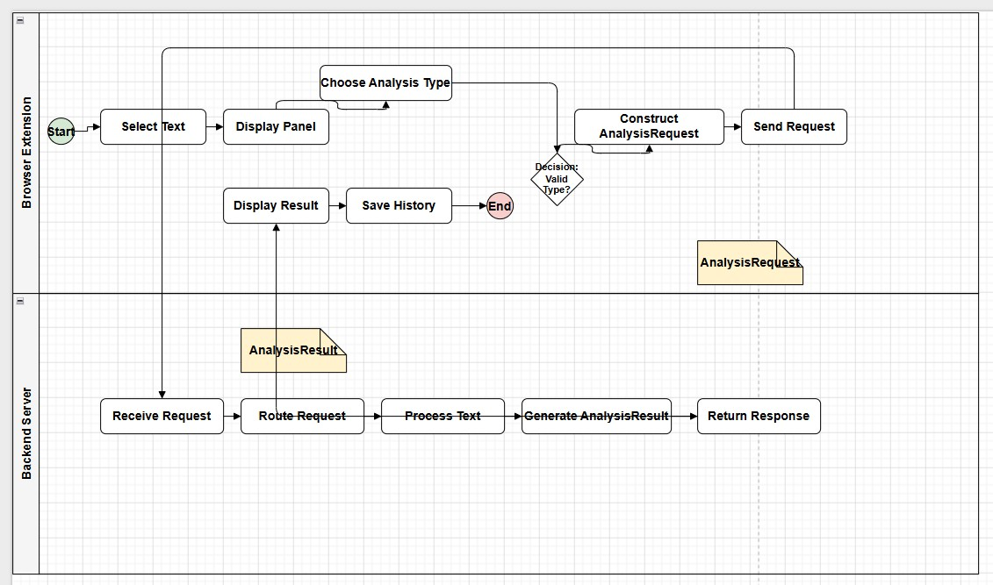
Figure 4.3: Refined Activity Diagram with Swimlanes

4.1.2 Component Diagrams
The component diagram describes the high-level software components of the AI Note Analyzer system and the interfaces through which they communicate. The system is composed of two major subsystems: the Browser Extension (client side) and the Backend Server (server side).
Browser Extension Components: The extension is structured into the following components: (1) Content Script (content.js) — injected into every webpage, responsible for detecting text selections and injecting the floating panel into the DOM; (2) Panel UI Component — the draggable, floating interface rendered in the browser, built using HTML, CSS, and JavaScript; (3) Background Service Worker — manages the extension's lifecycle, handles cross-origin API requests, and maintains the history store using the Chrome Storage API; (4) Options Page — allows the user to configure preferences such as the default analysis type and panel position; (5) Export Module — generates PDF and Markdown files from analysis results.
Backend Server Components: The server is structured into the following components: (1) API Gateway (FastAPI Application) — the entry point for all HTTP requests, implementing the REST endpoints defined in the refined class diagram; (2) Text Simplification Module (simplifier.py) — wraps the FLAN-T5 model with routing logic for short and long text inputs; (3) Question Generation Module (question_generator.py) — uses the FLAN-T5 model with concurrent generation to produce multiple questions; (4) Keyword Extraction Module (keyword_extractor.py) — implements the weighted TF-IDF pipeline with spaCy NER and positional scoring; (5) Difficulty Assessment Module (difficulty_detector.py) — computes the dual-metric difficulty score; (6) Model Loader — manages the loading and caching of FLAN-T5 model weights at server startup.
The Browser Extension communicates with the Backend Server exclusively through a RESTful HTTP interface over HTTPS. The Content Script and Background Service Worker communicate internally using the Chrome Extension Messaging API. The Backend Server components are loosely coupled through Python module imports, with the API Gateway acting as the sole entry point.
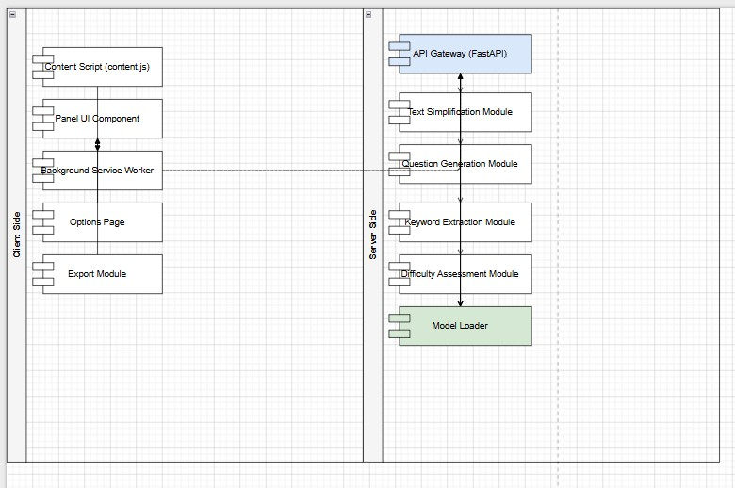
Figure 4.4: Component Diagram of the AI Note Analyzer System

4.1.3 Deployment Diagrams
The deployment diagram describes the physical architecture of the AI Note Analyzer system, showing how software components are mapped to hardware nodes and how nodes communicate.
Client Node — User's Computer: The user's computer runs a supported web browser (Google Chrome or Microsoft Edge). The browser hosts the AI Note Analyzer Extension, which consists of the Content Script, Panel UI, Background Service Worker, Options Page, and Export Module. The extension is installed from the Chrome Web Store or Edge Addons store. No additional software installation is required on the client side.
Server Node — Cloud Deployment (Render): The backend is deployed as a web service on the Render cloud platform, as defined in the render.yaml deployment configuration file. The server node runs a Python ASGI environment with Uvicorn as the server, hosting the FastAPI application. The FLAN-T5 model weights are loaded into memory at service startup. The server is accessible over the public internet via a secured HTTPS endpoint.
Communication: The client node communicates with the server node over the internet using HTTPS (port 443). The Chrome Extension Messaging API facilitates communication between the Content Script and the Background Service Worker within the client node. No direct database node is present in this deployment; analysis history is stored locally in the browser using the Chrome Storage API.
The deployment architecture ensures that the computationally intensive AI processing workload is handled entirely on the server side, keeping the client-side extension lightweight and responsive. The cloud deployment on Render provides scalability and eliminates the need for users to manage any local server infrastructure.

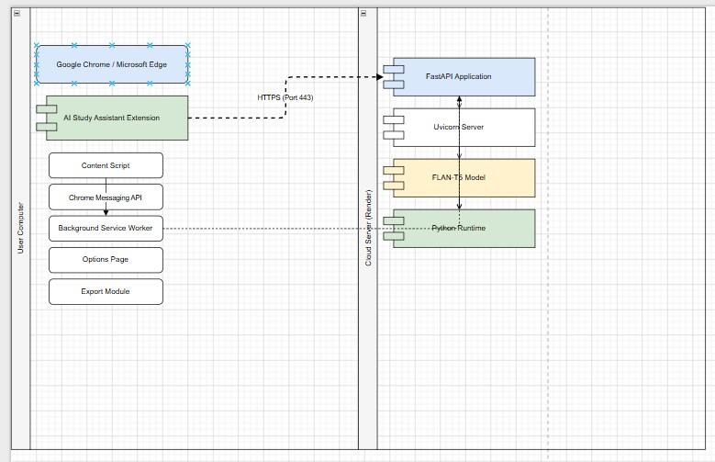
Figure 4.5: Deployment Diagram of the AI Note Analyzer System

4.2 Algorithm Details
This section describes the four core algorithms implemented in the backend processing pipeline. Each algorithm is invoked by the NLP service orchestrator when a text analysis request is received.

4.2.1 Text Simplification using FLAN-T5 Architecture
The text simplification module implements the FLAN-T5 instruction-tuning paradigm with a sentence-routing strategy. The algorithm operates as follows:
- The input text is tokenized into individual sentences using NLTK's sent_tokenize function.
- A routing decision is made based on sentence count. Texts containing five or fewer sentences are processed sentence-by-sentence using Mode A (fine-grained control). Texts with more than five sentences are processed in a single whole-text pass using Mode B (context-aware processing for longer inputs).
- In Mode A, each sentence is submitted to the inference engine with a FLAN-T5 style instruction prompt: 'Simplify this sentence for a student in plain English. Use simple words. Keep the same meaning. Output only the simplified sentence, nothing else.' Results are joined into a final simplified paragraph.
- In Mode B, the entire text is submitted with a whole-text instruction prompt that specifies: use simple vocabulary and short sentences, retain every main idea, add no new information, and output only the simplified text.
- Each inference result passes through two quality guards: a length guard (output shorter than 10 characters triggers a spaCy rule-based fallback) and an echo guard (more than 85% word overlap between input and output triggers the fallback). A post-processing step strips common LLM preamble artifacts from the output.
- The spaCy rule-based fallback splits the text on discourse connectors (however, therefore, furthermore, consequently, nevertheless) and returns the substantive clause parts as a simplified output.

4.2.2 Question Generation using FLAN-T5 Architecture
The question generation module uses a FLAN-T5-style Seq2Seq approach with concurrent per-sentence dispatching. The algorithm operates as follows:
- The input text is tokenized into sentences. Sentences shorter than 30 characters are filtered out. Near-duplicate sentences (matching on the first 60 characters) are removed. The remaining sentences are capped at MAX_QUESTIONS * 3 (15 sentences) to limit API calls.
- One question generation request is dispatched per selected sentence using a ThreadPoolExecutor with up to four concurrent workers. Each request submits the sentence with a structured instruction prompt: generate exactly one clear, specific question answerable from the sentence, starting with a recognised question word or auxiliary verb.
- Each generated question is passed through a cleaning and validation pipeline: only the first line of the output is retained, LLM preambles are stripped, the output must match a recognised question-start pattern, and the output must end with a question mark.
- Generic or too-short questions are discarded. Duplicate questions (matched on the lowercase, question-mark-stripped form) are removed. At most five unique questions are returned.

4.2.3 Keyword Extraction using Weighted NLP Scoring
The keyword extraction module implements a multi-signal weighted scoring pipeline using spaCy. The algorithm operates as follows:
- Candidate selection: tokens with Part-of-Speech tags NOUN or PROPN that are not stop words, are longer than two characters, are alphabetic, and are not in a predefined set of generic nouns are collected as candidates.
- Term Frequency scoring: each candidate lemma's frequency is counted and normalized by the total number of candidate tokens.
- IDF proxy scoring: a smoothed IDF score is computed as log((total_sentences + 1) / (sentences_containing_lemma + 1)) + 1.0. Lemmas appearing in every sentence receive lower scores.
- Base score is computed as TF multiplied by IDF. Four multiplicative boosts are then applied: Named Entity Recognition boost (x1.5 for tokens inside NER spans), noun-chunk-head boost (x1.2 for tokens that are the head of a noun chunk), firstsentence positional boost (x1.3 for tokens in the first sentence), and title-case boost (x1.1 for title-cased tokens that are not sentence-opening words).
- Per-sentence cap: at most two keywords are selected from any single sentence, choosing the highest-scored candidates from that sentence. This prevents long sentences from dominating the keyword list.
- The top twelve keywords by composite score are returned as the final output.

4.2.4 Difficulty Assessment using Dual-Metric Classification
The difficulty assessment module classifies text into three levels (Easy, Medium, Hard) using two independent readability metrics combined by a decision rule:
- The input text is tokenized into sentences and words. Average words per sentence (avg_words) is computed.
- Metric 1 (Words per Sentence): avg_words less than 12 maps to Easy; 12 to 20 maps to Medium; above 20 maps to Hard.
- Metric 2 (Flesch-Kincaid Grade Level): syllable count per word is estimated using a vowel-cluster proxy (counting groups of vowels a, e, i, o, u, y as syllable proxies). The simplified FK grade is computed as: FK = 0.39 x avg_words + 11.8 x avg_syllables_per_word - 15.59. FK below 6 maps to Easy; 6 to 10 maps to Medium; above 10 maps to Hard.
- Combined decision rule: if either metric produces Hard, the result is Hard. If both metrics produce Easy, the result is Easy. Otherwise the result is Medium.

CHAPTER 5: IMPLEMENTATION AND TESTING

5.1 Implementation

5.1.1 Tools Used
Table 5.1 lists all tools and technologies used in the development of the AI Note Analyzer Browser Extension.
Table 5.1: Tools and Technologies Used
Component | Technology Used
Browser Extension Interface | HTML, CSS, Vanilla JavaScript
Extension Framework | Chrome Extension API (Manifest V3, version 2.4)
Background Service Worker | background.js (Manifest V3 service worker model)
Backend Framework | FastAPI (Python, version 0.116.1)
Server Runtime | Uvicorn (ASGI Server, version 0.35.0)
AI Architecture (Simplification and Question Generation) | FLAN-T5 instruction-tuning prompt architecture with LLM inference (Groq API, llama-3.1-8b-instant)
NLP Processing (Keyword Extraction) | spaCy (en_core_web_sm, version 3.8.13)
NLP Utility (Sentence Tokenization) | NLTK (Natural Language Toolkit, version 3.9.1)
PDF Generation (Export) | FPDF2 (version 2.8.3)
Version Control | Git and GitHub
Cloud Deployment | Render (Singapore region, free tier, Python 3.11.9)

5.1.2 System Implementation

5.1.2.1 Browser Extension Module
The browser extension is developed using HTML, CSS, and Vanilla JavaScript, conforming to the Chrome Extension Manifest V3 (MV3) standard. It is structured into five distinct files, each with a specific responsibility.
The manifest.json file defines the extension's identity, permissions, and behavior. It declares the required permissions (activeTab, scripting, storage), registers background.js as the service worker, injects content.js into all URLs at document idle, and registers the Alt+S keyboard shortcut for toggling the analysis panel. The extension targets Chrome version 102 and above.
The background.js service worker handles two responsibilities: toggling the floating analysis panel when the extension icon is clicked, and responding to the Alt+S keyboard command by sending a toggle message to the active tab's content script.
The content.js file is the primary script injected into every webpage. It implements a double-injection guard to prevent re-initialization when the script is declared in content_scripts and also injected manually by the service worker. On boot, it reads the API base URL and character limit from chrome.storage.sync, and the analysis-enabled toggle state from chrome.storage.local. The script creates a singleton floating panel with a tabbed interface (Simplified, Questions, Keywords, Difficulty, History). The panel is draggable via mouse events on the header, minimizable, and closable. The text selection event listener fires on mouseup events, captures the selected text via window.getSelection(), enforces the 5,000-character limit with a visible notice, and calls the backend /analyze endpoint using the fetchAPI utility. The fetchAPI utility wraps the Fetch API with an AbortController configured to abort after 120 seconds, displaying a timeout message if the limit is reached. XSS protection is implemented through an escapeHtml function applied to all user-supplied content before insertion into the DOM. The status bar displays a summary of the analysis result including character count, difficulty level, and keyword count after each successful analysis. The options.html and options.js files implement the extension settings page, which allows users to configure the backend API URL, the maximum characters to analyze, and the PDF auto-redirect behavior. Settings are persisted using chrome.storage.sync for cross-session persistence.

5.1.2.2 Backend Processing Module
The backend is developed using FastAPI, a high-performance Python ASGI framework. The application is served by Uvicorn and deployed on the Render cloud platform (Singapore region).
The main.py file defines the FastAPI application with redirect_slashes=False to prevent silent 307 redirects on malformed URLs. It configures CORS middleware with allow_origins=["*"] and allow_credentials=False, which is the correct approach for a Chrome extension communicating with a remote server. Four endpoints are defined: POST /analyze receives a text payload and returns the complete analysis JSON; GET /history returns all stored history entries; DELETE /history/{id} removes a single entry by its UUID, with a guard rejecting empty IDs; and POST /export-pdf receives analysis data, generates a PDF using FPDF2 via a temporary file, streams it to the client using StreamingResponse, and deletes the temporary file using FastAPI's BackgroundTasks after streaming completes.
The nlp_service.py orchestrator initializes all service modules at startup by calling each module's init() function with the shared spaCy model instance and inference pipeline. The analyze_text() function sequentially invokes simplify_text(), generate_questions(), extract_keywords(), and detect_difficulty(), aggregates the results into a single dictionary, persists the result to history via history_manager.save_history(), and returns the aggregated result to the endpoint.
The model_loader.py singleton loader initializes the spaCy en_core_web_sm model once at application startup using a global variable guard, ensuring the model is loaded into memory only once regardless of the number of concurrent requests.

5.1.2.3 Inter-Module Communication
Table 5.2 describes the communication protocol between the browser extension and the backend server.

Table 5.2: Inter-Module Communication Protocol
Parameter | Value
Protocol | HTTP / HTTPS
Data Format | JSON (application/json)
Analysis Method | POST /analyze
PDF Export Method | POST /export-pdf
History Method | GET /history, DELETE /history/{id}
Client-side API | Fetch API with AbortController (120-second timeout)
Server Framework | FastAPI with Uvicorn ASGI
Backend Base URL | https://smart-study-assistant-9u6m.onrender.com

The communication flow for a standard analysis request is: (1) user selects text on a webpage, (2) content.js captures the selection and sends a POST request to /analyze with the text as JSON, (3) the backend processes the text through the NLP pipeline and returns a structured JSON response, (4) content.js parses the response and renders the results in the appropriate tabs of the floating panel, and (5) the result is saved to local history.

5.2 Testing
Testing was conducted in three phases: Unit Testing, Integration Testing, and System Testing. Manual testing was the primary approach, supplemented by functional validation at each module level across Google Chrome and Microsoft Edge browsers.

5.2.1 Unit Testing
Unit testing was performed on each individual module to ensure that each component functioned correctly in isolation. Test cases covered the text selection mechanism, each
NLP feature, the PDF export, the Markdown export, and the history management interface.

Table 5.3: Unit Test Cases
TC ID | Test Scenario | Testing Steps | Input Data | Expected Result | Actual  Result | Pass/Fail
TC01 | Text selection on webpage | 1. Open browser. 2. Navigate to any webpage. 3. Highlight a paragraph. | Any  English paragraph | Selected text captured and displayed in extension panel | As expected | Pass
TC02 | Text simplification with valid text | 1. Enable AI Analysis toggle. 2.  Select text. 3.  Observe  Simplified tab. | Complex academic paragraph | Simplified text returned in easier language | As expected | Pass
TC03 | Question generation with valid text | 1. Enable AI Analysis. 2.  Select text. 3.  Observe  Questions tab. | Any academic paragraph (4+ sentences) | At least one examoriented question returned | As expected | Pass
TC04 | Keyword  extraction with valid text | 1. Enable AI Analysis. 2.  Select text. 3. Observe  Keywords tab. | Any academic paragraph | List of meaningful keywords returned | As expected | Pass
TC05 | Difficulty assessment with valid text | 1. Enable AI Analysis. 2. Select short sentence then complex paragraph. | Short simple sentence vs complex paragraph | Correct difficulty level  (Easy/Medium/Hard) returned | As expected | Pass
TC06 | Simplification with no text selected | 1. Open panel without selecting text. 2. Observe panel behavior. | Empty  selection | Panel shows instruction to select text | As expected | Pass
TC07 | Text below  20-character  minimum | 1. Select fewer than 20 characters. 2. Observe panel. | Short word or phrase | Status bar prompts user to select more text | As expected | Pass

TC08 | Text above 5,000 character limit | 1. Select very long passage. 2. Observe panel status bar. | Text exceeding 5,000 characters | Text trimmed; notice shown in status bar | As expected | Pass
TC09 | PDF export after analysis | - Complete any analysis.  - Click  Export PDF. | Analysis results | PDF file downloaded to user's device | As expected | Pass
TC10 | Markdown  export after analysis | - Complete any analysis.  - Click  Export MD. | Analysis results | Markdown file downloaded, no backend call required | As expected | Pass
TC11 | History view — entries present | - Complete one analysis.  - Open  History tab. | Previously analyzed content | Analysis entry visible with timestamp | As expected | Pass
TC12 | History search filtering | 1. Open  History tab. 2. Type a keyword in search box. | Keyword  present in a past analysis | Only matching history entries shown | As expected | Pass
TC13 | History view  — no entries | 1. Open History tab with no prior analyses. | Empty local storage | Empty state message displayed | As expected | Pass
TC14 | Alt+S keyboard shortcut | 1. Navigate to any webpage. 2. Press Alt+S. | Any webpage | Analysis panel toggles open or closed | As expected | Pass

5.2.2 Integration Testing
Integration testing verified that the browser extension and the FastAPI backend communicated correctly, and that the outputs of each NLP module were properly assembled into a single structured JSON response.

Table 5.4: Integration Test Cases
TC ID | Test Scenario | Testing Steps | Input Data | Expected Result | Actual  Result | Pass/Fail
TC01 | POST /analyze with valid text | 1. Select text. 2. Trigger analysis. 3. Observe network request and response. | Valid English paragraph | HTTP 200; JSON  with simplified, questions, keywords,  difficulty fields | As expected | Pass
TC02 | POST /analyze with empty text | 1. Send POST with empty string. | {"text":  ""} | HTTP 422  Unprocessable  Entity | As expected | Pass
TC03 | FLAN-T5  simplification output | 1. Send text to backend. 2. Inspect simplified field in response. | Complex academic sentence | Simplified text field populated with readable output | As expected | Pass
TC04 | Question generation output | 1. Send text to backend. 2. Inspect questions field. | Paragraph with 4+ sentences | questions list populated with up to 5 items | As expected | Pass
TC05 | spaCy keyword extraction output | 1. Send text to backend. 2. Inspect keywords field. | Paragraph with clear nouns and technical terms | keywords list populated with relevant terms | As expected | Pass
TC06 | Difficulty assessment output | 1. Send simple then complex  text. 2. Inspect difficulty field. | Simple and complex paragraphs | Correct  Easy/Medium/Hard label returned for each | As expected | Pass
TC07 | Full response rendered in panel | 1. Complete  API round-trip. 2. Observe panel rendering. | Any valid text | All four result tabs  (Simplified,  Questions,  Keywords,  Difficulty) populated | As expected | Pass
TC08 | Backend unreachable — error handling | 1. Stop backend server. 2. Trigger analysis. | Any text | User-facing error message displayed with Retry button; no crash | As expected | Pass
TC09 | POST /exportpdf returns PDF | 1. Complete analysis. 2. Click Export PDF. 3. Observe download. | Analysis results | PDF downloaded; temp file cleaned up on server | As expected | Pass
TC10 | DELETE  /history/{id} removes entry | 1. Complete analysis. 2. Delete entry from History tab. | UUID of existing entry | HTTP 200; entry removed from  history list | As expected | Pass

5.2.3 System Testing
System testing evaluated the end-to-end behavior of the complete application, ensuring all components worked together seamlessly and that the system met its stated functional and non-functional requirements.
The system was tested with a variety of real academic paragraphs sourced from science textbooks, research abstracts, Wikipedia articles, and online lecture notes. Test scenarios covered normal usage flows, boundary conditions (texts of exactly 20 characters, texts of exactly 5,000 characters, single-sentence texts), and error conditions (network failure, backend cold start, unsupported characters).
Testing was conducted on Google Chrome (version 124 and above) and Microsoft Edge (version 124 and above) on Windows and Linux operating systems. After multiple rounds of testing across different machines and browser environments, the system consistently passed all major test scenarios. Key observations from system testing are as follows:
- Response time for text simplification and question generation averaged 3 to 6 seconds under normal network conditions on a warm backend server. First-request cold start on the Render free tier took 30 to 60 seconds, which is expected behavior documented in the extension README.
- Keyword extraction and difficulty assessment responded near-instantaneously (under 1 second) as these operations run within the backend NLP pipeline without remote inference calls.
- The PDF export feature produced well-formatted output files in all tested cases. Temporary file cleanup was verified to occur correctly after each streaming response.
- The Markdown export feature produced correctly formatted Markdown files entirely client-side, with no backend call required, and was verified to function even when the backend was unreachable.
- The history management interface correctly persisted and retrieved analysis records across browser sessions. The search filter correctly narrowed results in real time with no perceptible delay.
- The Alt+S keyboard shortcut reliably toggled the panel on all tested webpages, including dynamic single-page applications.
- The double-injection guard in content.js prevented duplicate panel creation in all tested scenarios involving both automatic content script injection and manual injection by the service worker.

5.3 Result Analysis
The AI Note Analyzer Browser Extension was evaluated based on the quality and accuracy of its four core output features across a diverse set of academic texts.
Text Simplification: The FLAN-T5 instruction-tuning architecture successfully reduced the reading complexity of academic paragraphs while preserving their core meaning. The sentence-routing strategy (sentence-by-sentence for texts of five sentences or fewer, wholetext processing for longer texts) produced consistent and coherent outputs. The quality guards (length guard and echo guard) correctly identified and discarded low-quality outputs in the cases where they were triggered, falling back to the spaCy rule-based simplification. Post-processing successfully removed LLM preamble artifacts in all tested cases.
Question Generation: The concurrent FLAN-T5-style Seq2Seq generation produced contextually relevant exam-oriented questions from a variety of academic texts. The per-sentence dispatching approach, combined with concurrent execution via ThreadPoolExecutor, improved overall throughput compared to sequential processing. Question Generation: The concurrent FLAN-T5-style Seq2Seq generation produced contextually relevant exam-oriented questions from a variety of academic texts. The per-sentence dispatching approach, combined with concurrent execution via ThreadPoolExecutor, improved overall throughput compared to sequential processing. Questions were grammatically well-formed and directly related to the input content. Quality-guard filtering and deduplication successfully removed generic, malformed, or repeated questions in all tested cases.
Keyword Extraction: The weighted TF-IDF-style scoring pipeline accurately identified domain-relevant nouns, proper nouns, and named entities. The combination of NER boost, positional boost, and noun-chunk-head weighting ensured that the most conceptually important terms received higher scores. The per-sentence cap (maximum two keywords per sentence) successfully prevented long sentences from dominating the keyword list. Results were consistent and meaningful across different academic subject areas including science, history, and technology.
Difficulty Assessment: The dual-metric classifier (words-per-sentence combined with Flesch-Kincaid grade level) produced more reliable difficulty labels than the single-metric approach used in the mid-defence version. Simple texts (short sentences, common vocabulary) consistently received Easy ratings. Dense academic texts with long sentences and polysyllabic vocabulary consistently received Hard ratings. The combined decision rule (Hard wins; Easy only if both agree) provided a conservative and appropriate assessment for ambiguous texts.
Overall, the system demonstrated practical effectiveness as an AI-powered academic support tool, successfully achieving all stated objectives within the defined scope. All specific objectives stated in Section 1.3 were met.

CHAPTER 6: CONCLUSION AND FUTURE RECOMMENDATIONS

6.1 Conclusion
The AI Note Analyzer Browser Extension has been successfully developed, tested, and deployed as a practical, AI-powered tool designed to assist students in comprehending academic content more effectively. The system integrates a lightweight Chrome and Edge browser extension with a FastAPI-based backend server to deliver four core functionalities: text simplification, exam-oriented question generation, keyword extraction, and difficulty assessment, all in real time, directly within the user's browsing environment.
The project was developed following the Agile (Scrum) methodology, which allowed iterative refinement of features based on testing outcomes and evolving requirements. All eight specific objectives stated at the outset of the project have been successfully achieved.
The text simplification module implements the FLAN-T5 instruction-tuning paradigm with a sentence-routing strategy and quality-guard mechanisms, producing consistently readable outputs from complex academic texts. The question generation module uses a concurrent FLAN-T5-style Seq2Seq approach with per-sentence dispatching and deduplication filtering, generating up to five contextually relevant practice questions per analysis. The keyword extraction module implements a weighted multi-signal scoring pipeline using spaCy, incorporating Term Frequency, IDF proxy, Named Entity Recognition, positional weighting, and noun-chunk-head detection, with a per-sentence cap to ensure diverse keyword coverage. The difficulty assessment module employs a dual-metric classifier combining words-per-sentence analysis and a simplified Flesch-Kincaid grade level formula, providing more reliable difficulty labels than a single-metric approach.
Beyond the four core NLP features, the final system includes a PDF export feature powered by FPDF2, a Markdown export feature that operates entirely client-side without a backend call, a real-time history search, a keyboard shortcut (Alt+S) for panel access, a configurable options page, and a background service worker. These features collectively deliver a complete and polished academic support tool.
The backend has been successfully deployed to the Render cloud platform (Singapore region) and is accessible at https://smart-study-assistant-9u6m.onrender.com. The browser extension has been packaged and published as extension.zip for direct installation on Google Chrome and Microsoft Edge. The project makes a meaningful contribution toward bridging the gap between the availability of digital academic resources and the ease of understanding them.

6.2 Future Recommendations
Although the AI Note Analyzer Browser Extension meets its stated objectives and is fully operational, several enhancements can be pursued in future development cycles to expand its capabilities and improve its performance:
- Multi-Language Support: The current system supports English text only. Future versions could integrate multilingual NLP models to support additional languages such as Nepali, Hindi, or French, making the tool accessible to a broader range of students.
- Improved AI Model Fine-Tuning: The FLAN-T5 instruction-tuning architecture, while effective, can be further improved by fine-tuning on academic domainspecific datasets. This would enhance the quality of simplification and question generation outputs for highly specialized content areas such as medicine, law, or engineering.
- Advanced Difficulty Assessment: The current dual-metric difficulty engine can be extended with a machine learning-based readability model trained on features such as Coh-Metrix or Dale-Chall vocabulary scores, providing more nuanced and accurate assessments for specialized academic texts.
- User Authentication and Cloud Sync: Implementing user account management would allow analysis history to be stored on the cloud and synchronized across multiple devices, significantly improving the utility of the history management feature beyond the current local storage approach.
- Personalized Learning Support: The system could be extended to track the topics a user frequently analyzes and provide personalized study recommendations, flashcard generation, or concept maps based on usage patterns.
- Offline Processing Support: Integrating a smaller, locally deployable language model (such as a quantized version of FLAN-T5) would enable text simplification and question generation without requiring an internet connection, eliminating the cold-start latency of the free-tier cloud deployment.
- Support for PDF Documents: A future version of the extension could explore approaches to safely intercept and analyze text from PDF documents opened in the browser, expanding the scope of content the system can process.
- Support for Additional Browsers: Extending compatibility to Firefox, Safari, and other major browsers beyond Chrome and Edge would significantly broaden the user base of the extension.
- Integration with Learning Management Systems: Future development could explore direct integration with platforms such as Moodle, Google Classroom, or Microsoft Teams to embed the study assistant into existing academic workflows and enable features such as shared study notes and collaborative annotations.

REFERENCES
- C. Raffel, N. Shazeer, A. Roberts, K. Lee, S. Narang, M. Matena, Y. Zhou, W. Li, and
P. J. Liu, "Exploring the Limits of Transfer Learning with a Unified Text-to-Text Transformer," Journal of Machine Learning Research, vol. 21, no. 140, pp. 1-67, 2020.
- H. W. Chung, L. Hou, S. Longpre, B. Zoph, Y. Tay, W. Fedus, Y. Li, X. Wang, M. Dehghani, S. Brahma, and A. Webson, "Scaling Instruction-Finetuned Language Models," arXiv preprint arXiv:2210.11416, 2022.
- X. Du, J. Shao, and C. Cardie, "Learning to Ask: Neural Question Generation for Reading Comprehension," in Proceedings of the 55th Annual Meeting of the Association for Computational Linguistics (ACL), 2017, pp. 1342-1352.
- M. Heilman and N. A. Smith, "Good Question! Statistical Ranking for Question Generation," in Proceedings of the NAACL-HLT 2010, 2010, pp. 609-617.
- R. Mihalcea and P. Tarau, "TextRank: Bringing Order into Text," in Proceedings of the 2004 Conference on Empirical Methods in Natural Language Processing (EMNLP), 2004, pp. 404-411.
- S. Bird, E. Klein, and E. Loper, Natural Language Processing with Python.
Sebastopol, CA: O'Reilly Media, 2009.
- D. Jurafsky and J. H. Martin, Speech and Language Processing, 3rd ed. Stanford
University, 2023. [Online]. Available: https://web.stanford.edu/~jurafsky/slp3/
- Chrome Developers Documentation, "Chrome Extension Development Guide," 2024.
[Online]. Available: https://developer.chrome.com/docs/extensions/

APPENDIX A: GITHUB REPOSITORY AND CODE STRUCTURE
Repository Link: https://github.com/Yugalpoudel07/smart-study-assistant.git
The complete project directory structure is provided in Section 5.2 of this report. The repository contains all source code for the browser extension and the backend server, along with the deployment configuration, build scripts, and the packaged extension.zip for installation.

APPENDIX B: SCREENSHOTS OF THE SYSTEM
The following figures present screenshots of the AI Note Analyzer Browser Extension as captured during system testing. Images should be inserted in the spaces indicated below.

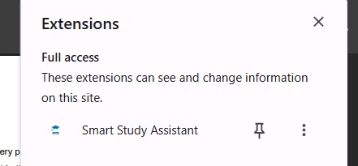]

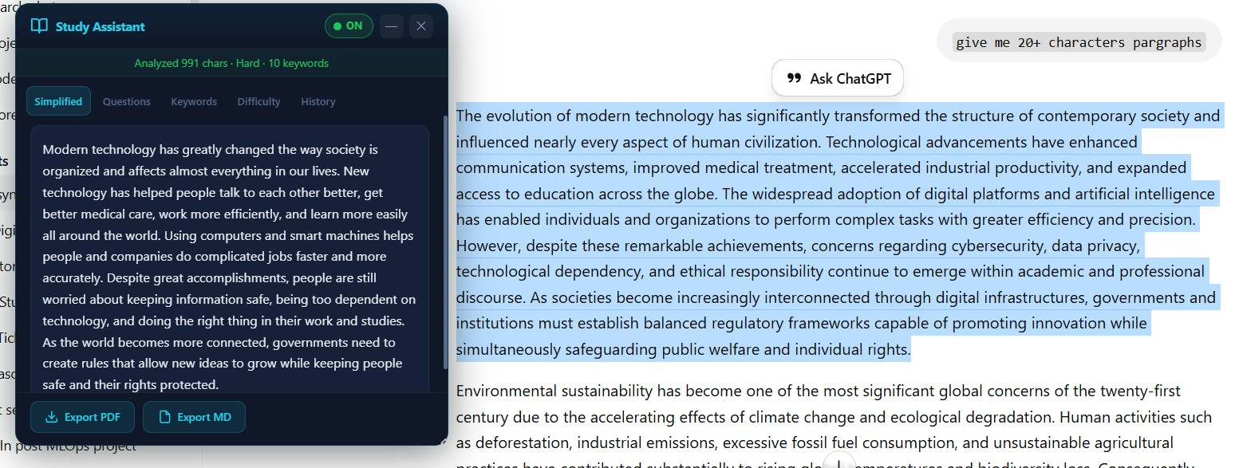

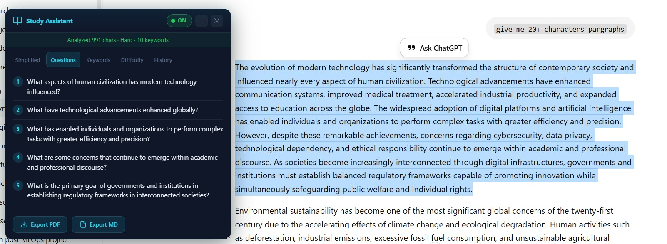

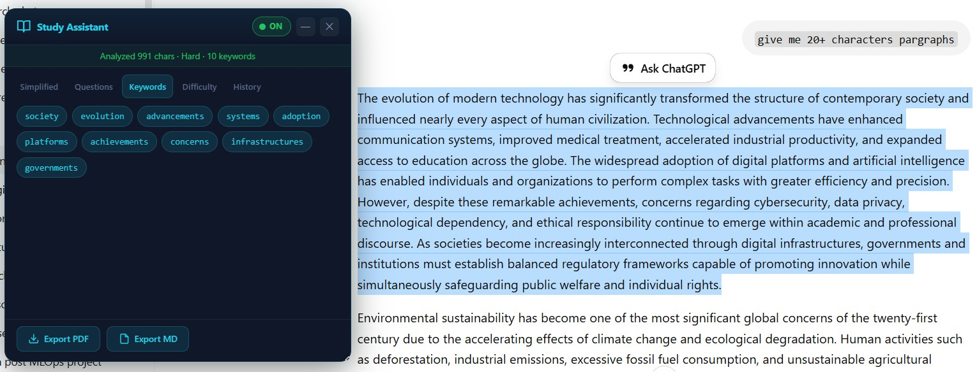

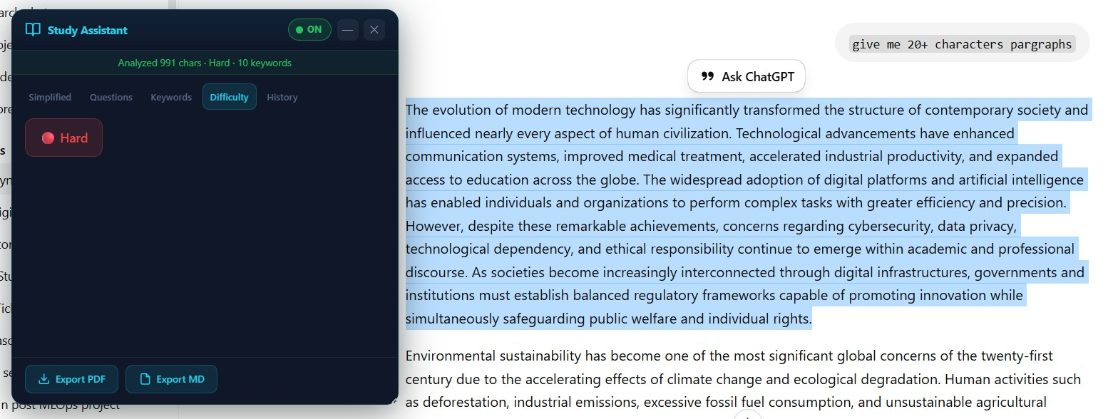

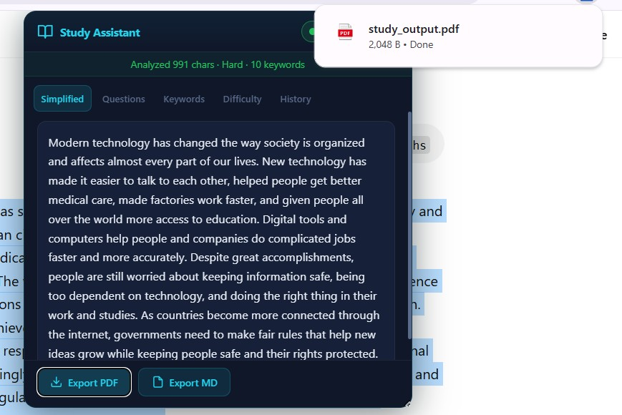
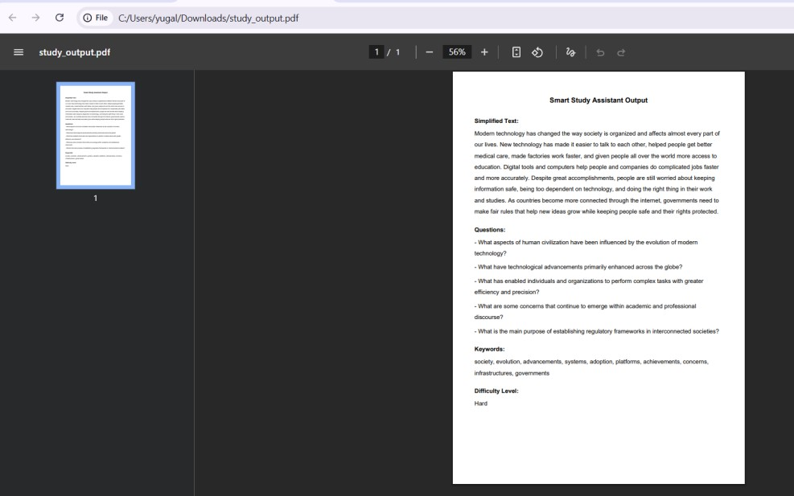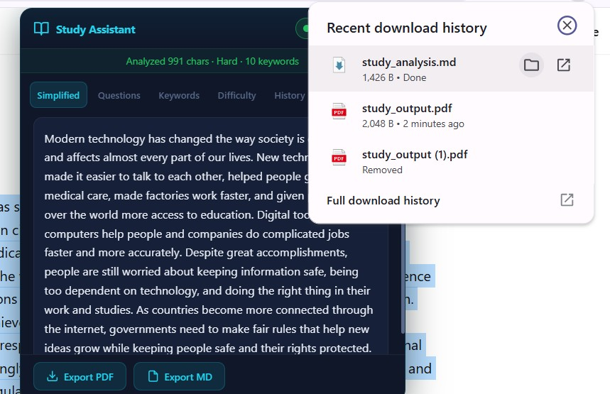

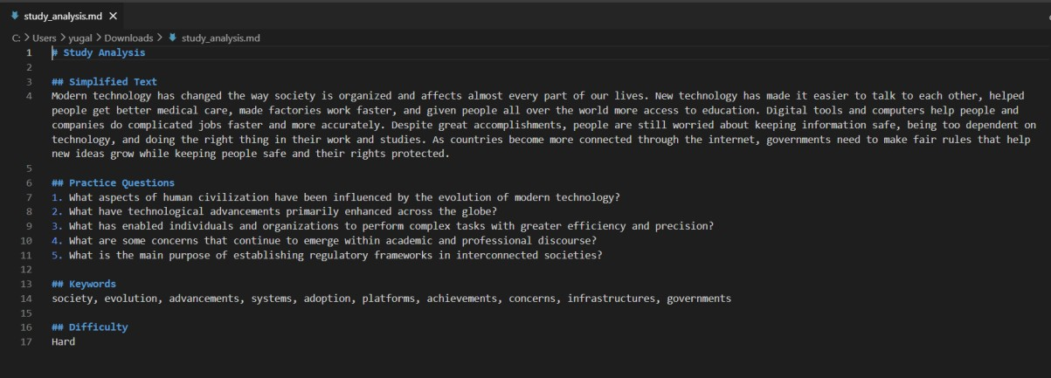

APPENDIX C: MAJOR SOURCE CODE SNIPPETS

C.1 content.js — Text Selection and API Call Logic
// Fetch with AbortController timeout (120 seconds) async function fetchAPI(url, options = {}) { const controller = new AbortController(); const timer = setTimeout(() => controller.abort(), 120_000); try {
const resp = await fetch(url, { ...options, signal: controller.signal
});
clearTimeout(timer); return resp; } catch (err) { clearTimeout(timer); if (err.name === 'AbortError') { const timeoutErr = new Error('Request timed out after 120 seconds'); timeoutErr.isTimeout = true; throw timeoutErr;
} throw err;
}
}

C.2 main.py — FastAPI Endpoint Definitions
@app.post('/analyze') def analyze(req: TextRequest): return analyze_text(req.text)

@app.get('/history') def history(): return get_history()

@app.delete('/history/{item_id}') def delete_history(item_id: str): if not item_id or not item_id.strip(): raise HTTPException(status_code=400, detail='item_id is required') success = delete_history_item(item_id) if not success:
raise HTTPException(status_code=404, detail='History entry not found') return {'status': 'deleted'}

C.3 simplifier.py — FLAN-T5 Routing Strategy
def simplify_text(text: str) -> str: sentences = sent_tokenize(text) sentence_count = len(sentences) if sentence_count <= 5:
return _simplify_sentence_by_sentence(sentences) else:
return _simplify_whole_text(text)

C.4 keyword_extractor.py — Weighted Scoring Pipeline
# Composite scoring with boosts boost = 1.0
if token.i in ner_set: boost *= 1.5 # NER boost if token.i in chunk_head_set: boost *= 1.2 # noun-chunk head boost if _is_title_cased_non_start(...): boost *= 1.1 # title-case boost if s_idx == 0: boost *= 1.3 # first-sentence boost score = (tf_score * idf_score) * boost

C.5 difficulty_detector.py — Dual-Metric Classification
def detect_difficulty(text: str) -> str: avg_words = total_words / num_sentences avg_syllables = total_syllables / total_words fk_grade = (0.39 * avg_words) + (11.8 * avg_syllables) - 15.59
# Combined decision rule if wps_level == 'Hard' or fk_level == 'Hard':
return 'Hard' if wps_level == 'Easy' and fk_level == 'Easy':
return 'Easy' return 'Medium'

C.6 question_generator.py — Concurrent Question Generation
def generate_questions(text: str) -> list[str]:
sentences = _select_sentences(text) with ThreadPoolExecutor(max_workers=_MAX_WORKERS) as executor:
future_to_idx = { executor.submit(_generate_question_for_sentence, sent): idx for idx, sent in enumerate(sentences)
} for future in as_completed(future_to_idx):
idx = future_to_idx[future] results[idx] = future.result()

C.7 render.yaml — Cloud Deployment Configuration
services: - type: web
name: smart-study-assistant-9u6m runtime: python region: singapore plan: free rootDir: backend buildCommand: pip install -r requirements.txt && python -m spacy download en_core_web_sm
startCommand: uvicorn main:app --host 0.0.0.0 --port $PORT envVars:
- key: GROQ_API_KEY sync: false - key: DISABLE_HISTORY value: true

